CASE STORY
HealthNet TPO and LIMPAL, ‘Women as Central Agents for Peacebuilding in Colombia’

This is the story of Sonia, resident of Vistahermosa (department of Meta, Colombia) now happily married with three children. She is a survivor of gender-based violence and a devoted women rights leader. She considers herself a driven and collaborative woman and she enjoys participating in all activities realized by our partner LIMPAL (Colombian branch of the Women’s International League for Peace and Freedom).

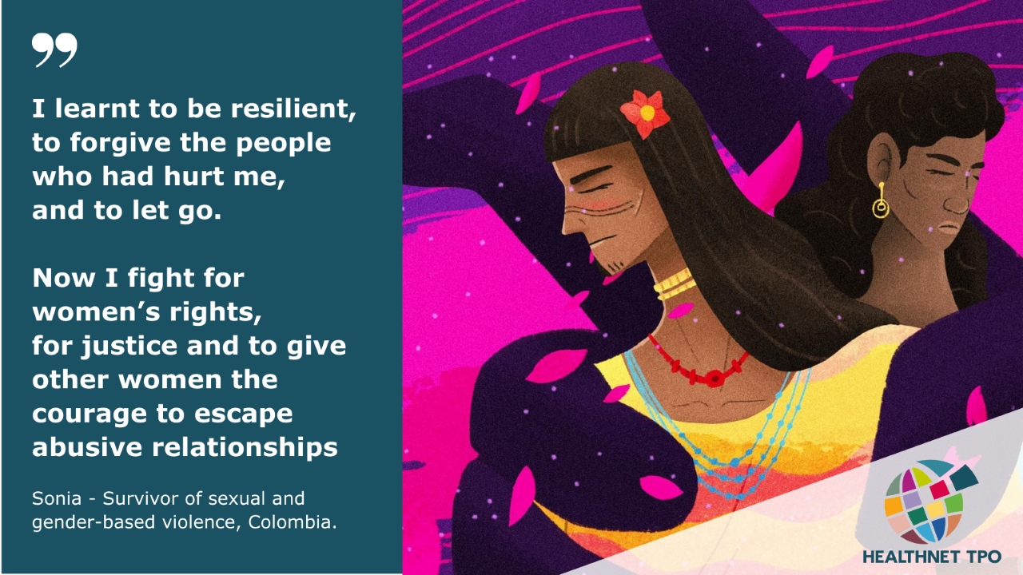

When I was a child, I suffered from violence and for that reason I decided to leave home – I was just 5 years old. I went through the Colombian Family Welfare Institute and then I had to leave from there. I got a job and I found LIMPAL within the framework of the Women as Central Agents for Peacebuilding project in Colombia. Since joining the program I have changed. I started to meet more people and LIMPAL helped me understand my problems and find a solution. They taught me to be resilient, to forgive the people who had hurt me and to let go. I showed myself that I could get ahead, I could have a quieter life and continue without the emotional burdens that had only made me sick.

I want to continue learning more to defend the rights of women. I also long to have a decent job to be able to buy a lot, build it little by little and, in this way, not continue paying rent. Although I have many financial needs, I have managed to have other things such as recognition from other women and the satisfaction of doing things for women who need my help.

Before being part of the NAP program, I was a victim of domestic violence by two of my ex-partners. During the activities, I met more women and started becoming more sociable. Previously I used to be antisocial because of what happened in my past. Likewise, my way of thinking and being in my romantic relationships improved thanks to this beautiful process of which I was part. After the program I was left with the gift of being part of the citizen oversight Brave Women (“Mujeres Valientes”), which monitors referrals of cases of gender-based violence in the municipality of Vistahermosa, and this allows me to learn and fight for women’s rights. Here I have created strong friendships with many women, who have given me their support and have also been my counselors.

Unlike some years ago, I now can see that one of my great transformations has been the ability to express myself in public. I was a very reserved person and I did not tell my life to anyone because it caused too much pain. But thanks to LIMPAL I learned not to burden myself with my problems and to understand that everything has a solution. Before, I did not have a good relationship with my husband, we had no communication, but now everything has changed, we talk more and we are compassionate and loving. We are now a team and when we have differences we talk to reach an agreement. We don’t want anything to come between us, so that we stay together for our 3 children and the love that we feel for each other.

I thank LIMPAL for all they have done to change my life. I see myself now as a transformed woman. In my childhood I lived through harmful experiences that have marked my life as an adult and brought me bitterness. Now I am able move on from that pain and to let go. Every day I get up more eager to fight for the women who need my help. I want to teach my daughter that as women we are a treasure and we must value ourselves. I have learned to give myself courage as a woman and in the same way to value the company of the people around me. I have acquired the courage to motivate other women to denounce their aggressors, and during the time that I have been a part of the citizen oversight I have become a stronger woman. The work I do with the Brave Women is a legacy for my daughters. I am empowered and I dream of being able to create a foundation which aims to help women who suffer from any kind of violence. I dream of a community free from gender-based violence, a more inclusive and just community, a community with values and principles.

This case study is carried out in the first person at the request of the interviewee.

