KarAmoja, ugANDA
Reflections from EKISIL’s Women Peace Forum work in Karamoja (Mercy Corps- EKISIL Program).
January 2022
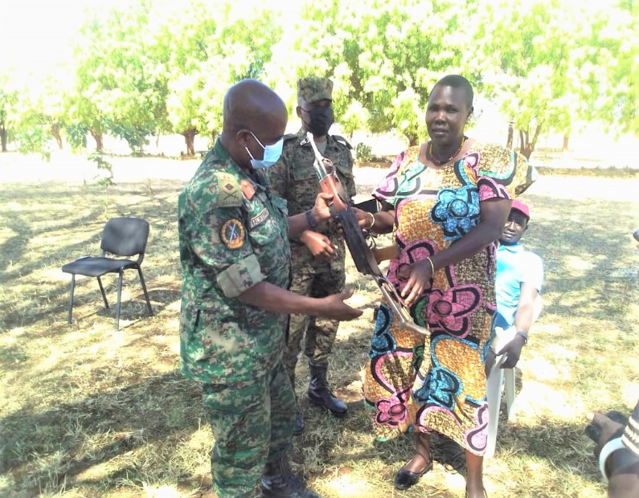

Photo: EKISIL 2021, Member of WPF handing over recovered gun to the UPDF Army Officer in Moroto district-Uganda

About the EKISIL program
The EKISIL is implementing a five-year program in Karamoja with the goal of helping male and female adults and youth secure a more peaceful and prosperous future. The Securing Peace and Promoting Prosperity in Karamoja (EKISIL) is a Conflict Mitigation and Management Project that uses the people-to-people approach (P2P) to bring groups together across divisions to address underlying social, economic, ecological, and governance issues at risk of fueling conflict in the Karamoja region. This is achieved through three interlinked objectives that address root causes of inter-ethnic conflict and promote reconciliation, empower local capacities to prevent and manage conflicts, and address emerging conflicts related to land.
The program addresses governance, economic, social, and ecological issues that risk igniting conflict in Karamoja. The program brings together ethnic groups to address social challenges, such as trauma, and support cooperation on natural resources to overcome ecological causes of conflict, such as degraded pasture. EKISIL links women, through women’s forums, councils of elders, and youth groups, to formal governance structures and the private sector to address weak governance of natural resources and economic drivers of conflict. This includes the loss of livelihoods from the acquisition of land by the government and extractive industries. The project brings Karamoja communities together across lines of conflict to address the social, economic, environmental, and political issues at risk of fueling violence by targeting close to 3,000 direct beneficiaries. The targeted population projection of 623,600 (including indirect beneficiaries) is the whole population of the four districts (Moroto, Kotido, Kaabong and Abim) in Karamoja.

The cycle of violence in Karamoja
The persistent conflict amongst the 10 clans in Karamoja has historically created a hotbed for violent livestock raids and inter-district inter-ethnic clashes that reinforce a vicious cycle of violence. While men are traditional power holders, Karamojong women also play a significant role in fueling conflict by encouraging their sons to raid cattle and marrying off their teenage daughters to gain more wealth. Caught at crossroads they, however, often find themselves both the victims and perpetrators of conflict.
In response to these dynamics and in line with its gender strategy, EKISIL Activity designed a comprehensive strategy to work with WPF in peace building processes in Moroto, Kotido, Kaabong and Abim districts of Karamoja, a largely agro-pastoralist sub-region of northeastern Uganda. The Activity through Women Peace Forum initiatives focused on addressing power imbalances between men and women to break down traditional norms that limited women role in both private and public spaces. It was also aimed at opening social spaces and enhance more meaningful public participation of women in decision making structures in the districts of operation in Karamoja.
Beyond Karamoja, EKISIL Activity through its Women Peace Forum initiative compliments a larger international movement, advancing the United Security Council Resolutions 1325 and 1820 on Women Peace and Security; as well as the Ugandan and United States of America Governments National Action Plans on 1325 and 1820. WPF (Women Peace Forums) exemplifies how international policies can be translated into meaningful actions that meet the needs of rural communities.
The stories from Women Building Peace tell of the exceptional experiences of individuals, families, communities reflecting on how power imbalances, culture, history, and other dynamics can fuel violence. Through the project, communities have taken responsibility for peace building including both ending violence against women and supporting women to use their power to foster peace. However, opportunities remain to strengthen achievements and start new initiatives. Through Women Peace Forum, the women in Karamoja have transcended cultural boundaries and raised their voices in a call for more peaceful communities. Below are some of the achievements registered by the women peace forum in Karamoja.
Gun recoveries and support to disarmament exercise: To date, the women have recovered a total of 74 guns directly from the community and successfully handed to the army. These recoveries were either done through community outreach activities (advocacy, awareness, and sensitization initiatives). For example, Ms. Stephany Namer, a member of the WPF presided over a delicate mediation process in Tapac (Moroto district) that resulted into the handover of three (03) guns and amnesty for warriors who handed them over. A total of 60 people attended. Of the three guns recovered, one gun (handed over on June 11) was used by a warrior in a neighboring district and killed a security officer before raiding an unspecified number of animals. The warrior feared arrest and reprimand but mediation efforts by Stephany between the community, warriors, and security forces, resulted into handover of the gun and amnesty for the warrior
Women healing and reconciling communities through EKISIL Trauma Informed Community Empowerment Approach in Karamoja: Following the escalations of conflicts in Karamoja associated with cattle thefts/raids most communities lost livestock and lives resulting to the deep-rooted trauma within communities. The Women Peace Forum in Karamoja earmarked communal healing processes through providing psychosocial services, healing social bonds and trauma inflicted by the raids and loss of lives, they formed women structures in the communities to lead the process of healing and reconciling communities, as result there is minimal cycle of revenge among communities, challenges associated with revenge and building trust among formerly conflicting communities. These has encouraged communities to hold peace dialogue meetings with conflicting communities to harness the trust leading to community social reconciliation.
Women peace forum leading a process of management of natural resources through facilitating Natural Resource Sharing Agreements. In such ecologically vulnerable region as Karamoja, conflict is inevitable given the disparity between the availability of the conflicted natural resources, and the demand to use them. This is worsened by the increasing populations of cattle and humans and competition for access to the diminishing resources. Scramble for pasture and water during dry spells often results into conflict due to lack of proper border demarcations and unresolved past grievances between the communities. The women peace forum collaborated with the Kaabong and Kotido district local governments to facilitate and support conflicting communities engage in a yearlong process of resource sharing that culminated into signing of the two natural resource sharing agreements on February 8, 2019, and February 9, 2019”. The RSAs spell out modalities and mechanisms of pasture and water sharing, preventive mechanisms, guarantors of the agreement and traditional justice system to deal with violations. The signed agreements significantly led to reduction in violent conflict and cattle thefts, increase in informal trade, improved communication between the Jie and Dodoth, strengthened relations and laying ground for social reconciliation among the conflicting communities and Built resilience capacities to shocks and stresses.
Mediation of 20 conflicts around extractives, GBV and land: Covid19 pandemic and the containment measures instituted by government affected so much people’s livelihoods. The closure of mining sites and markets for extractives had serious toll on the livelihoods of the artisanal miners who initially depended on livestock trade. Many traders resorted to black markets and negative copying strategies that escalated conflicts. In March 2020 for example, conflict broke out between the local (host) community and foreign miners resulting from perception around the spread of covid, an incident which resulted to attempted eviction of over 250 foreign artisanal miners in Nakabat, Rupa sub county Moroto district. On notice, the women peace forum members together with the district COVID 19 task force intervened as mediators between the two communities amicably leading to the resettlement of 200 evicted foreign miners. The team additionally sensitized the community and their leaders on how to mitigate the risk of the pandemic while emphasizing the benefits of peace and harmonious coexistence with the miners and accepting them back into the community. This led to the return and resettlement of over 200 miners and their families and are now peacefully trading together.
Recognition of Women’s Peace Forum members by the Minister for Karamoja Affairs and the First Lady: The good work being done by the WPF has not gone unnoticed. In August 2020, the Women’s Peace Forum members led several peace building initiatives including participation in radio talk shows, organizing, and mobilizing the community to participate in peace dialogues, engaging political and technical leaders to support and participate in the peace process. This led to the recovery of several illegal guns from the community, an activity that has seen a reduction of firearms among the community. The above work of the Women’s Peace Forum members has been welcomed and recognized by the community, and government institutions, CSOs including the office of the First Lady and Minister for Karamoja Affairs. For example, as an appreciation and recognition of the work being done by the WPF, the First lady and Minister of Education and Sports gave each of the selected 20 women peace forum members a sum of USD $1,635 each for their tremendous work and accomplishments.
Women advocating for anti FGM, and alcoholism in Karamoja: Most of the drivers of conflicts and raids have been attributed to alcoholism and alcohol abuse. In addition, alcoholism has also been reported to have occasioned early marriages, increased mortalities and FGM practices in the region. In Tapac sub county-Moroto district for example, the WPF members innovatively used drama shows at Kosiroi mining sites to demonstrate the negative effects of alcohol consumption, and FGM. An initiative which has since registered positive results including the passing of alcohol consumption as by law by the sub county administration and catholic church in Tapac sub county, development and popularizing the referral pathways to report FGM related activities and created awareness on the dangers of alcohol and FGM. As a result,15 girls who had crossed to Kenya for circumcision returned home uncircumcised, having realized its negative effects among others.
Sensitization and resolving GBV cases: The long-term closure of schools led to increased number of teenage pregnancies, and rape cases within the Karamojong communities. A case in point was a rape case of an underage girl in Rupa sub county, Moroto district. The WPF took a lead role in organizing meetings to support the raped girls with the aim of ensuring the victims get support and justice. several arrest of the rape culprit were handed over to police while they supported the girls in getting proper medical attention at Moroto Regional Referral Hospital. The fear of legal consequences has resulted in a reduction in the number of rape cases in the region. Additionally, 20 girls who were formerly rape victims have returned to school and are now in candidate classes.
Women’s influence in peace building before, during and after elections: Election period in Uganda has been characterized by increased level of violence and related human rights violation especially illegal arrest and detention of political opponents, fights between different political camps, intimidation, shootings, and gun related deaths. With mainly men and youth being the target and victims., As mothers, between September 2020 and January 2021, the Women Peace Forum members decided to take up the responsibility of talking to their children/youth, men/husbands in Karamoja to desist from negative/illegal electoral activities that might result into violence, harm, and death. This includes sensitization and advocacy on the use of non-violent communications during campaigns, respect of individual ideologies and use of vote to elect leaders. the strategy used involved; door-to-door peaceful campaigns, use of media e.g radios, WhatsApp to disseminate messages of peace during elections and call for government to respect the views of electorates. As a result, no major violent incidences were registered before, during, and after elections, unity has continued to prevail between the winners and losers and service delivery has continued to flourish. As such the women have earned respect, recognition, and awards from different leaders across the region including His Excellency the President of the Republic of Uganda who invited the women for meeting in Kyankwanzi to further strengthen their role in the region in February 2021. During the meeting, the women were able to lobby the president to prioritize many issues, which includes, establishment of another brigade in north Karamoja, and disarmament, the pledge the president honored and promised to fulfil. As part of appreciation, the president pledged to provide iron sheets to all the Women’s peace forum members to construct decent houses for themselves.
Challenges and gaps faced by women in Peace building: Women efforts in peacebuilding in Karamoja have been constrained by several factors which include; Transport constraints to reach far distances to sensitize the communities, Intimidation by peace spoilers and individuals who are benefiting from the illegal acts, cultural rigidities that portray women as inferior gender, high poverty levels and biting hunger at the household levels that divert the attention of the women, minimal facilitation for women in peace building among other.

CONTACT
Mark Guti-Chief of Party | Securing Peace and Promoting Prosperity-EKISIL
+256772822394/+256770829286
mguti@mercycorps.org

