Product Description: Below is a success story describing the ways in which innovative and interactive trainings on gender-equality and empowerment could lead to engaging men and boys in promoting and advancing women’s rights in a predominantly patriarchal society.
Country: Occupied Palestinian Territory (oPt)
Year: 2022
Project Title: We Rise: Palestinian Women and Girls Lead and Engage on Women Peace and Security in occupied Palestinian territory (oPt)
Outcome: Enhanced prevention and protection of women and girls from violence and human rights violations.
Output 1.2: CBOs, community actors and government service providers have the knowledge, skills, capacity to promote and respond to the needs of women and girl survivors of SGBV.
1.2.1. Build partnership with local youth CBOs and developing capacity of youth CBOs management and ongoing mentoring to promote women's rights in their communities

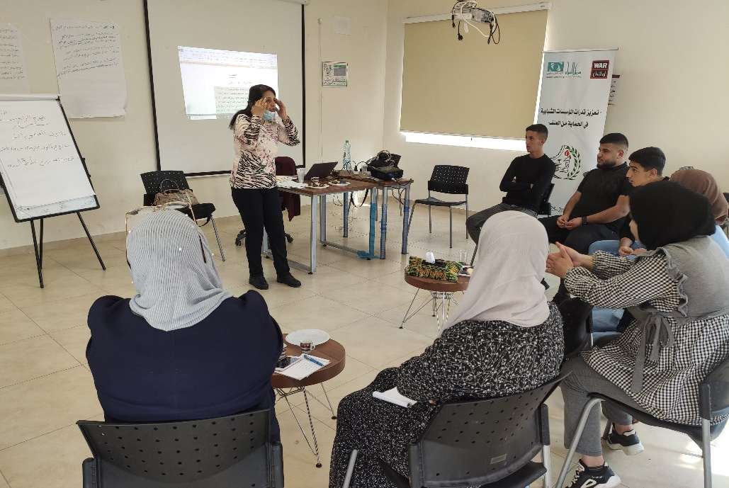
The We Rise project was designed through a holistic lens in order to address many of the barriers facing Palestinian women in leading the journey towards peace and security. Through a consortium of highly influential civil society and international organizations, the project adopted a community-based approach that optimized efforts in advancing the WPS agenda. In doing so, the consortium focused on engaging youth while focusing on young men in order to reinforce positive male engagement and work towards transformative change.
WCLAC (Women’s Center for Legal Aid and Counseling) is among the pioneering organizations within the We Rise consortium. WCLAC worked on mapping nine youth-based-organizations in Bethlehem area and identified Nibras, a youth CBO in Dar Salah village in Bethlehem. Through Nibras, WCLAC worked on implementing a capacity building program to raise awareness on gender equality and human rights in addition to a training package focused on mobilizing young men to transform restrictive gender norms. The training targeted a diverse group of participants and tackled issues facing both men and women living in a patriarchal society.
Among the participants, two young men expressed their ideas against gender-equality and dismissed discussions surrounding supporting women’s participation in leadership and decision-making positions. However, the training managed to challenge these young men’s ideas and negative perceptions of gender-equality. The training was very innovative and hosted a safe space for participant’s to debate and discuss their thoughts about the concept of gender, gender-equality, and gender roles. The two young men engaged in rigorous discussions that triggered many questions including questioning their own thoughts and preconceived ideas of women empowerment.
Upon the completion of the training, WCLAC team were surprised when these two young men volunteered to conduct awareness raining sessions in their local communities. They were very eager to share their new understanding of gender and women empowerment to their peers, schools, and families.
Nevertheless, after completing the capacity building and training packages, these wo young men carried out awareness raising sessions themselves on women rights and gender equality for other male students in the local schools of their villages. Today, these two young men have led various awareness sessions with young male students from their local schools. They have become champions and positive examples for other young men in the village. They have also become women’s strongest allies in the pursuit of gender-equality and empowerment.

