*WILPF heeft een Consultatieve Status bij de Verenigde Naties, ECOSOC, UNCTAD en UNESCO en speciale consultatieve relaties met FAO, ILO en UNICEF*

**ADRESSEN:**

**Website**: [www.wilpf.nl](http://www.wilpf.nl)

**Van WILPF-international**:

[www.wilpfinternational.org](http://www.wilpfinternational.org)

E-mailadres: secretariat@wilpf.ch.

**Voorzitter:** Aynur Tekin:  [aynur__tekin@hotmail.com](mailto:aynur__tekin@hotmail.com)

**Secretaris**: vacature

**Penningmeester**: Rosan Huizinga

0345 615105

[huiz.klopp@planet.nl](mailto:huiz.klopp@planet.nl)

**IB-lid:** Willo Buskens

[adbura@kpnmail.com](mailto:adbura@kpnmail.com)

**Alternative IB lid**

Aynur Tekin

[aynur__tekin@hotmail.com](mailto:aynur__tekin@hotmail.com)

**Vertegenwoordiger van de Werkplaats**:

Anke Kuiper

[anke.kuiper@inter.nl.net](mailto:anke.kuiper@inter.nl.net)

**Ledenadministratie:** Rosan Huizinga [huiz.klopp@planet.nl](mailto:huiz.klopp@planet.nl)

Rekeningnummer: NL 33 INGB 0000 236494

**Redactie Nieuwsbrief:**

Loes Pihlajamaa 043 4571860

Redactieadres: Pastoor Pendersstraat 9,

6262 PB Banholt [loesp@cuci.nl](mailto:loesp@cuci.nl)

Alle vragen en opmerkingen aan het Algemeen Bestuur kunnen gestuurd worden naar [info@wilpf.nl](mailto:info@wilpf.nl) of

Secretariaat WILPF Nederland Laan van Nieuw Oost Indië 252, 2593 CD Den Haag

Erelid:

Carlota Lopes da Silva

**Kopij voor de volgende nieuwsbrief: uiterlijk 30 september 2021, bij voorkeur per e-mail (**[**loesp@cuci.nl**](mailto:loesp@cuci.nl)**)**

**INHOUD**

Oproep van de penningmeester: 2

WILPF in solidarity with Palestinians 2

*WILPF nl bij ondertekening NAP IV 3*

In Memoriam Carla de Wit 4

Actiemaand September 2021:

KERNWAPENVRIJ EUROPA !!!!! 5

How ‘Good’ Social Movements Can Triumph over ‘Bad’ Ones 6

Global Zero Applauds Warren

and Smith's 'No First Use Act' 9

The Women’s Health Pioneer

You’ve Probably Never Heard Of 10

In Memoriam Hanna Deelman 13

Bericht van PAX 15

Nobel Peace Prize Winner

Jody Williams Slams Biden Admin

for Claiming Landmines

Are a “Vital Tool” 15

Nederlandse feministe

Aletta Jacobs inspireert Argentijnen 18 Gedicht 20

-----------------------------------------------------------

**AGENDA: geen gegevens ontvangen**

**----------------------------------------**

**Van de redactie**

Nu het er op begint te lijken dat de coronacrisis begint weg te ebben, tenminste in ons deel van de wereld, begint het er helaas ook op te lijken, dat de mensheid er niet veel van geleerd heeft – zoals we een jaar geleden nog hoopten. Toch mogen we wel hopen dat men nu beter weet dat samenwerking bitter nodig is bij een crisis. Als die les maar een beetje wordt toegepast in de strijd voor een gezond klimaat, en een gezonde wapenbeheersing (bestaat die?), is er ook hoop voor verbetering. In deze nieuwsbrief in elk geval leesstof genoeg, ook over inspirerende mensen…

Ik wens u alleen een mooie zomer.

*Loes Pihlajamaa*

**Oproep van de penningmeester:**

**Beste WILPF-leden,**

**Als je de contributie voor WILPF NL 2021 nog niet hebt betaald………graag nog even doen!!!!!**

**Alvast dank,**

**Rosan H.**

--------------------------------------------------------------

**Bankrek: NL33 INGB 0000 2364 94, tnv WILPF Nederland**



**UN Human Rights Council, 30th special session on the grave human rights situation in the Occupied Palestinian Territory, including East Jerusalem**



**Joint statement by the Women’s International League for Peace and Freedom and the Women’s Centre for Legal Aid and Counseling (WCLAC)**

The Women’s International League for Peace and Freedom (WILPF) stands in solidarity with the Palestinian people. WILPF and the Women’s Centre for Legal Aid and Counselling (WCLAC) strongly support the creation of a Commission of Inquiry whose mandate addresses both the root causes of Israel’s systemic discrimination and the violations of rights of Palestinians on both sides of the Green Line. What is happening in Sheikh Jarrah in East Jerusalem is a result of the international community’s failure to address the root causes of the systematic violence inflicted on Palestinians in the Occupied Palestinian Territories, including East Jerusalem, and in Israel.

As UN experts of this Council have stated, “*the enemies of accountability are impunity and exceptionalism.”* The impunity of Israel and the states which are complicit results in escalations of violence as witnessed the past few weeks. It must no longer be tolerated. The apartheid settler colonial policies pursued by Israel result in crimes against human humanity and other violations of the human rights of Palestinians. The continued illegal annexation of Palestinian land, the systemic oppression and institutionalised discrimination, the bombing of populated areas, and other human rights violations have devastating impacts on the lives of Palestinians.

Women and girls are differently impacted. They are disproportionately impacted by consequences of explosive weapons and forced displacements due to their roles as primary caregivers of their families and managers of household livelihoods.

Similarly, the 14-year-long blockade imposed on Gaza and the recurrent military offences against the enclave have resulted in a double burden on women. Such specific impacts must be investigated and addressed including through the mandate of the Commission of Inquiry the Council will establish. And the participation and voices of Palestinian women must be ensured. It is unconscionable that States — including the USA, Germany, Italy, UK and Canada — still supply weapons and other military assistance to the Israeli government, despite the clear risk of serious violations of international human rights law and international humanitarian law.

The Human Rights Council must:

• Ensure that gendered impacts are investigated and addressed;

• Recommend an immediate and comprehensive arms embargo;

• Urge all parties to end the use of explosive weapons in populated areas;

• Strengthen its scrutiny of Israeli and foreign companies that continue to benefit from the occupation, such as those with business ties to Israeli settlements.

***WILPF NL heeft NAP IV ondertekend: hier de ‘pitch’, die is uitgesproken door Rosan Huizinga bij het NAP ‘signatory event’ , 10 juni j.l., waarbij nieuwe organisaties zichzelf presenteerden.***

**WILPF, Women’s International League for Peace and Freedom**

Is the oldest organisation worldwide of women for peace and freedom, found-ed in 1915 in The Hague by women from European countries and the US on a 3-day conference called:  **‘The International Congress of Women’ with the aim to ‘discuss the principles of constructive peace’.**

The delegates, from neutral and warring countries, were disgusted and appalled by the violence and the slaughter and convinced that there should be other and better ways to resolve international conflict.

They passed 20 resolutions, amongst them

- Organisation of a Society of Nations on the basis of constructive Peace

(now UN)

- a permanent International Court of Justice

- general disarmament; with control of production and international trade of arms

- women’s right to partici-pate on an equal basis in all political and decision making processes in society.

**2.**

In 2015 WILPF has cele-brated in The Hague its 100-years existence, participa-ting several generations of women committed to the original vision and ideals.

Today WILPF is a member-ship organisation, with some 40 national sections in all continents; in its Constitution the first principle reflects the original inspiration **‘To bring together women of different political beliefs and philosophies who are united in their deter-mination to study, make known and help abolish the causes and legiti-mization of war.’**

**The three International Programmes** determine the focus of activities, campaigns and research:

**Disarmament** (including nuclear disarmament),

**Human rights** (Women’s rights are human rights)

**Peace Women** (Women Peace and security).

**3.**

**WILPF and WPS/NAP 1325**

Since the adoption of Resolution 1325 by the UN Security Council and the development of National Action Plans, WILPF International plays a central role in the WPS and 1325 scene and WILPF-NL members have been parti-cipating in the shaping and implementation of all former Dutch NAPs, as do other sections in their own coun-tries. Regarding the Dutch NAP and in alliance with WILPF Int., WILPF NL pretends to contribute to the overall goal of WPS strengthening.

As WILPF NL is a small organisation with volunteers only we choose our pro-grammatic focus following urgent developments and working together with other European sections. Therefore, our main efforts are focused on Disarma-ment, the UN-Treaty Pro-hibiting Nuclear Weapons, Military budgets and NATO-expansion plans. In line with our focus areas, we aspire to contribute more specifi-cally to NAP 3.3 sub-out-come to improve imple-mentation of article 7.4 of the Arms Trade Treaty. Our activities include information dissemination and consci-ousness-raising (3-monthly magazine), lobbying, cam-paigning together with likeminded action groups, Ngo’s and platforms, nati-onally and internationally.

Finally, we are in direct contact with our WILPF section in Colombia LIMPAL, co-implementor of a NAP-funded project. Our WILPF liaison in the Dutch NAP will be Karin Verbaken, since more than 10 years participating in the Dutch 1325 community.

**In Memoriam Carla de Wit**

Op 12 mei is Carla de Wit overleden, een hard werkende en bescheiden vrouw, die veel deed voor de vrouwenvredesbewe-ging. Zij maakte concreet werk van haar betrok-kenheid met vrouwen, vrede en politiek.

In 1972 werd haar ge-vraagd om secretaresse te worden van Marga Klompe, die inmiddels de actieve politiek had ver-laten, maar zich wel met allerlei maatschappelijke zaken bezig hield. Een unieke kans voor Carla. Ze kreeg interessante en actuele zaken onder ogen o.a. op politiek gebied.

Marga Klompe kreeg in 1979 het verzoek van de Zwitserse Aline Boccardo om een Nederlandse afdeling van Vrouwen voor Vrede op te richten. Deze brief heeft Carla doorgespeeld naar Maria Ter Steeg en zo is Carla vanaf het begin betrokken geraakt bij de “Vrouwen voor Vrede” in Nederland.

Ze was er voornamelijk in de groep “Overheid en Politiek” dagelijks mee bezig, en met haar kennis van zaken beïnvloedde zij zo de landelijke politiek. Het was de tijd van acties en demonstraties (o.a. tegen kernwapens). De naam van de groep veranderde met het samengaan van WILPF in de “Politieke Werk-groep”.

De groep , waarin ook Leny Durville, Mans van Zandbergen, Han Deggeller en Lies Jansen zaten, had vanaf de jaren 80 gesprekken met Kamerleden, ministers en de minister president (Lubbers). “*Daar waren ze destijds nog toe bereid”*, aldus Carla in een interview, *“tegen-woordig hebben politici geen tijd meer voor dergelijke persoonlijke contacten”.*

Via Vrouwen voor Vrede kwam Carla bij de WILPF (heropgericht) terecht. Het internationale ka-rakter van WILPF trok haar aan. Ze maakte o.a. samenvattingen van de Nieuwsbrief van WILPF in het toenmalige blad voor Vrouwenbelangen.

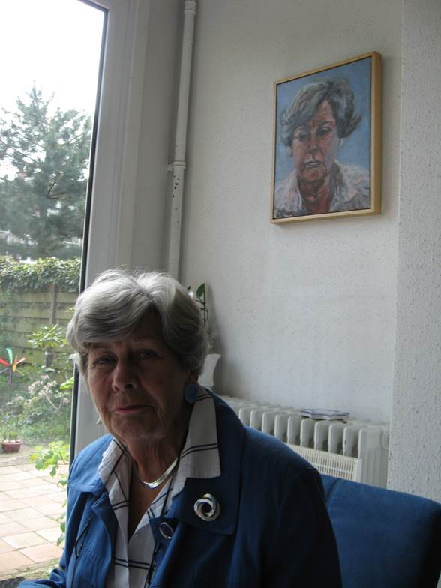

Met Leny Durville had Carla een hechte band. Ze waren jarenlang (vredes) vriendinnen. Vroeger werden ze bij WILPF “onze Haagse dames” genoemd. Ze waren vanaf de oprichting van WILPF zeer betrok-ken leden. Ze kenden het netwerk in den Haag en de Tweede Kamer. Daar heeft de werkgroep veel aan gehad, doordat zij bijv. afspraken met Buza en Defensie regelden. Ondertussen hielden ze ook zorgvuldig het Europabeleid bij.

Toen er voorbereidingen getroffen moesten worden voor de viering van het 100 jarig bestaan van WILPF in het Vredes-paleis in Den Haag, was Carla, inmiddels al aardig op leeftijd, zeer gastvrij tijdens de bijeenkomsten van de z.g. Haagse Groep, o.l.v. Mans van Zandbergen. Bij Carla thuis werd menigmaal vergaderd en uitgebreid geluncht.

WILPF is haar zeer er-kentelijk voor haar inzet en voor haar tomeloze energie in het accuraat bijhouden van materiaal in de vorm van actuele artikelen, brochures, nieuwsbrieven etc. Zij was op hoge leeftijd, evenals Leny Durville, aanwezig bij bijeen-komsten van WILPF en deed op bescheiden wijze haar woordje met kennis van zaken.

Haar bescheidenheid bleek uit een interview waar ze toen alles aan bod was geweest op het laatst zei: “*O ja, dat is waar ook, ik ben in 2009 Vredesvrouw van het jaar geworden samen met An van Sabben”.*

*Anke Kuiper*

Nieuw boek van

**Ray Acheson**:

**‘Banning the Bomb, Smashing the Patriarchy’**

‘*tells the story of seven decades of activism transforming an impossible dream into international law’*

Ray Acheson is directeur van het Disarmament Program van WILPF [www.reachingcriticalwill.org](http://www.reachingcriticalwill.org))en bestuurslid lid van ICAN (International Campaign to Abolish Nuclear Weapons) [www.icanw.org](http://www.icanw.org) .

ICAN kreeg in 2017 de Nobel Vredesprijs.

Het boek Is bij Bol.com te bestellen.

**Actiemaand September 2021:**

**KERNWAPENVRIJ EUROPA !!!!!**

Het samenwerkingsverband van verschillende vredesorganisaties en Ngo’s ‘No-To-NATO ([www.no-to-nato.org](http://www.no-to-nato.org)) heeft een actiemaand georganiseerd met acties in verschillende Europese landen.

Doel is te protesteren tegen de Amerikaanse kernwapens die opgeslagen zijn in landen als België, Nederland, Duitsland, Italië en om politici op te roepen het UN Verdrag op het Verbod op Kernwapens te ondertekenen.

Op de website [www.nukefreeeurope.eu](http://www.nukefreeeurope.eu) kun je de laatste stand van zaken m.b.t. de voorbereiding vinden, o.a. een fietstocht door België , Nederland (Volkel!), Duitsland en Frankrijk.

**Onderteken de petitie!**

ook te vinden op de website [www.nukefreeeurope.eu](http://www.nukefreeeurope.eu)

**How ‘Good’ Social Movements Can Triumph over ‘Bad’ Ones**

*Social scientists have identified factors shaping the likelihood that emancipatory social movements will succeed in bringing tangible change*

*By*[*Gilda Zwerman*](https://www.scientificamerican.com/author/gilda-zwerman/)*,*[*Michael Schwartz*](https://www.scientificamerican.com/author/michael-schwartz/)*on March 16, 2021*

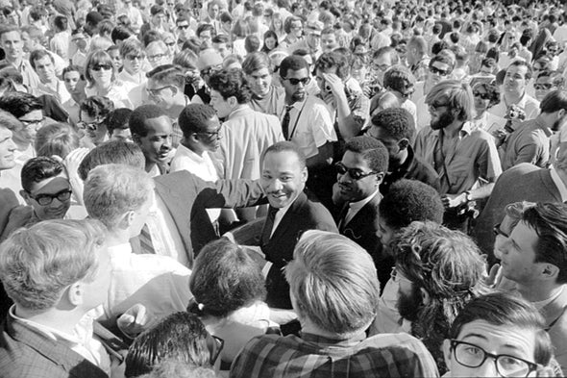

In June 2015, a white supremacist opened fire inside the historic African Methodist Episcopal Church in Charleston, South Carolina, killing nine black congregants, including the minister. The massacre sparked a crescendo of anti-racist protest, including often successful demands for the removal of statues of Confederate Generals from public spaces throughout the South.

Two years later, a coalition of white nationalists arrived in Charlottesville, Virginia, for a “Unite the Right” rally aimed at protesting and reversing the local City Council’s decision to remove from the city’s center of a hundred year-old statue of Confederate General Robert E. Lee.

Also gathered in Charlottesville were civil rights activists who sought to support the city’s resolve in removing the statue, and to press for further reforms aimed at dismantling institutional white supremacy. The event turned violent after the white nationalists attacked the racial justice advocates with tiki torches, pepper spray and lighter fluid. Fights erupted, injuring at least 30 people. The weekend of protest ended when one of the white nationalists deliberately rammed his car into a crowd of antiracist counter-protesters, injuring 19 and killing one. Refusing to condemn either the goals or the actions of the white nationalists, President Trump [commented](https://www.politico.com/story/2017/08/15/full-text-trump-comments-white-supremacists-alt-left-transcript-241662) that there were “*very bad people … and very fine people on both sides.*” Trump was correct about that. In this encounter between white nationalists and civil rights activists, there were undoubtedly good *individuals*and bad *individuals*on both sides. How, then, can we judge which *movement* was the “good” one and which the “bad?”

The answer can be found in the sociological study of social movements. Over decades of focused research, the field has demonstrated that evaluating the moral compass of individual participants does little to advance our understanding of the morality or the actions of a large movement. Only by assessing the goals, tactics and outcomes of movements as *collective phenomena* can we begin to discern the distinction between “good” and “bad” movements.

Modern social movement theory developed from foundational studies by several generations of scholars, notably [W.E.B. DuBois](https://www.amazon.com/Black-Reconstruction-America-Oxford-Bois-ebook/dp/B00IJC320G/), [Ida B. Wells](https://www.amazon.com/Southern-Horrors-Lynch-Phases-Hardcover/dp/138786341X/), [C.L.R. James](https://www.amazon.com/Black-Jacobins-Toussaint-LOuverture-Revolution/dp/0679724672/), [E.P. Thompson](https://www.amazon.com/Making-English-Working-Class/dp/0394703227), [Eric Hobsbawm](https://www.amazon.com/Primitive-Rebels-Eric-Hobsbawm/dp/0349143013/), [Charles Tilly](https://www.amazon.com/mobilization-revolution-Charles-Tilly/dp/0201075717/) and [Howard Zinn](https://www.amazon.com/Peoples-History-United-States-ebook/dp/B015XEWZHI/). Their works analyzing “large” historical processes provided later social scientists with three working propositions.

**First,** the morality of a movement is measured by the type of change it seeks. “Good” movements are emancipatory: they seek to pressure institutional authorities into reducing systemic inequality, extending democratic rights to previously excluded groups, and alleviating material, social, and political injustices. “Bad” movements tend to be reactionary. They arise in response to good movements and they seek to preserve or intensify the exclusionary structures, laws and policies that the emancipatory movements are challenging.

**Second**, large-scale institutional changes that broaden freedom or advance the cause of social justice are rarely initiated by institutional authorities or political elites. Rather, most social progress is the result of pressure exerted from the bottom up, by ordinary people who press for reform by engaging in collective and creative disorders outside the bounds of mainstream institutions.

And **third**, good intentions—aspiring to achieve emancipatory goals—by no means guarantee that a movement will succeed.

The highly popular and emancipatory protests of the 1960s, as well as the influence of groundbreaking works in social history mentioned above, inspired a [**renaissance**](https://www.scientificamerican.com/article/the-power-of-social-justice-movements/) in the study of social movements in subsequent decades. Focusing primarily on “good” movements, a new generation of social scientists sought to identify the environmental circumstances, organizational features and strategic choices that increased the likelihood that “good intentions” would translate into tangible change. This research has generated a rich trove of findings:

* Successful movements must define their goals clearly and target the institutions that have the power to make the changes they are demanding.
* Successful movements should act in a political environment in which they have leverage to demand systemic change. Authorities who control institutional policy grant concessions only when organized disruptions are more damaging to their continued power than giving in to the demands of the movement.
* Successful movements must include the rank and file of the constituencies they are representing in decisions concerning goals and tactics. Often this involves working in tandem with organizations that link the movement to the communities that will benefit from the movement’s success.
* Successful movements should cultivate “conscience” constituencies—sympathizers, celebrities, patrons—who may not directly benefit from the movement’s goals but are willing to contribute money, facilities, equipment, access to media and other [resources](https://www.jstor.org/stable/2777934).
* Successful movements cannot be “greedy.” They must recognize and respect members’ private lives and personal obligations, prepare participants for the dangers and risks of each protest, and allow each individual to choose—without coercion—which actions they are [willing to take](http://www.jstor.org/stable/1395252).
* Successful movements generate the solidarity needed to undertake collective action by creating an active and supportive internal life and culture among their participants. The internal life of a movement should prefigure the emancipatory changes sought in the broader society. It should offer interactional and decision-making opportunities not available outside the movement, including social and cultural events that are enriching and fun, and which build the mutual trust necessary for sustaining collective action
* Successful movements must anticipate repression, including stand-offs with institutional authorities, forcible dispersal by police, confrontations with counter-protesters, long-term interference from intelligence agencies, and mass arrests.
* Successful movements implement processes that allow for effective collective responses to repression--including strategic retreat, enduring repression, active confrontation, and escalation of protest.

And still, there are no guarantees of success. Because social movements form organically, outside of mainstream institutions, they are by nature [messy](https://www.scientificamerican.com/article/well-never-fix-systemic-racism-by-being-polite/). Rarely does meaningful change happen by relying exclusively on peaceful and lawful means. Petitions, marches, litigation, and chanting are only part of the protest repertoire. Achieving systemic change invariably requires [creating disorder](http://www.africa.upenn.edu/Articles_Gen/Letter_Birmingham.html): social movements gain leverage when they disrupt business-as-usual for the institution they are targeting—by stopping traffic, blocking commerce, surrounding buildings or interfering with administrative activities. Generations of activists, as well as the scholars who study social movements, have been challenged by the need to deploy effective strategies when nonviolent disruption reaches an impasse without generating concessionary responses; or when it provokes violent responses by the police or by counterdemonstrators aimed at defeating the demands for institutional change.

Faced with severe repression, good movements typically retreat. But dispersing a disruptive action can often guarantee failure, because the movement may not have the capacity to rebuild its strength and recapture the leverage. The alternative is to hold their ground, facing off with police or counterdemonstrators, thus prolonging and intensifying the disruption. The police and counterdemonstrators, who aim to dismantle the protest, must therefore target the bodies of activists. The human casualties that can occur on both sides can, in an instant, transform a site of protest into a sensationalized event, drawing attention away from the political aims of the movement.

Sites of protest are thus both vibrant and vulnerable. But social movements that are attempting to ameliorate “big” social problems and gaping contradictions in the democratic order—economic inequities, racism, patriarchy—are [long-term processes](https://www.jstor.org/stable/3660172). As such, the clash between white supremacists and racial justice activists that took place in Charlottesville in 2017 should be viewed as a recent “moment” in the long civil rights movement that began at the end of the Civil War. Persistence—sustaining commitment, perhaps over the course of a lifetime; expanding networks while forming and reforming coalitions; assessing failures and devising new strategies; exploiting new political opportunities with fresh tactical repertoires; and integrating new generations into the life of the movement—is key to assuring further moments of success. As the pioneers of social history have shown, this is how “bad” movements are defeated and “good” changes are won.

Gilda Zwerman is professor of sociology and criminology at SUNY Old Westbury. She studies social movements with a special focus on activists imprisoned for participation in political violence.

AlMichael Schwartz is Distinguished Teaching Professor, Emeritus, at Stony Brook University

*Source: Scientific American*

# Global Zero Applauds Warren and Smith's 'No First Use Act'

*15 April 2021*

Today, U.S. Senator Elizabeth Warren (D-MA) and Chairman of the House Armed Services Committee Adam Smith (D-WA) [reintroduced](https://u1584542.ct.sendgrid.net/ss/c/P8Elou2Rvc0qoMPEUZrMXbPt9DtWiRK2ny-iNaVBWE6t0CRG8Ehv5fd1JMa6v40t8XGBnwgsFpSLpNTLjlNf8QdE4sfw-aqPqJapIU3W7NiBymvrDso41-Qvh5EY1D6oMpj1lzX9VoHNQUcmUP2falOMqjSNSrtrurNEnMmvXfHXpousykWjNEtZMpVNvKkgtRcm66ev_rjSuExe4lp7Om6r83Kx3VjhBwyFy1Eby6VRIrX39GinqelsryXasIMch8Rgh6GRgOXUHoIiA4rTG5jWA4dMqxX0q498l6SL6Chz2UWT7qGIFrEhf4G9qfP3UcqxVTl6gkMSy58qn_bpuTUgk5SmeNbV5mIPxGCac2z_BY62Hx8HtGNlcsJF00Uj9YqE_pZBqgoDXq6Tv6hcIVphL34k88Ke6przuhRuPO0/3b3/SvSl6095Rj-i84jlVJDF0g/h0/v-46348THV4NKU5NGV6VovqFTP34tJzKxej_NwYmLr0) the “No First Use Act,” which, if it becomes law, would reduce the risk of nuclear conflict by legally obligating the United States to never use nuclear weapons first in a crisis or conflict.

**In reaction to the announcement, Derek Johnson, chief executive officer of Global Zero, the international movement for the elimination of nuclear weapons, issued the following** [**statement**](https://u1584542.ct.sendgrid.net/ss/c/atcYNHk4Eh2YdGnwBh-YDIDb64HC4y_XQmLhWPTiPr7wa6vV8EEeBULLaT6oHIVt7oWaqQsK_ppEo0-OqMg6s4IjhSm3QcGbNH8I64P1eCO84_ExZqqE-DgLWt-TK9GIibH2BE7p0Vjl6LjoQu2W8FGuTRaDjdPXK1xUYZ4zBmcw7mqrIxTOsBbZyawYKDwDkovF8L7WN0_WoeDDCAu1M68PCjXFwSsQnj1yN0-kjsIYLcrCJpJiSTArsojTwpugC5qfcFW7Afd9eO-qDITpcTRdtyZFGdzqvaZW4yusBYJM5XH7AlcJqOT1DNchM0KFUqjOr3nyPIfAmwsxCx_kdv7dCE398-ipyrptUBcUS8SGi1JR-KPHtPWqswBdl3yzmxkB6XPSx1XagUmiQzHAA73bVkf9bcnUkxXb1Gy7AsuzEwn1-mWb1vlFib05OGZoWueciEjdf3megBCuSsChZQ/3b3/SvSl6095Rj-i84jlVJDF0g/h1/X5F0oGNxVsHP-n7GhbsjlX1EftiWlmNEV47HcFvxk74)**:**

“Today’s re-introduction of the No First Use Act is an important step to enhance American and global security by helping ensure nuclear weapons are never used again. This is common-sense legislation that makes Americans, and the world, safer and more secure. It is long past time for the United States to adopt a realistic policy that forgoes the possible first use of nuclear weapons.'The risks that nuclear weapons will be used are unacceptably and unnecessarily high. The major risk of nuclear use today comes from the danger that a small or accidental clash or conflict will escalate quickly through confusion or fear and cross the nuclear threshold. America’s decades-long policy of threatening its own possible first use of nuclear weapons only adds to this danger. Codifying No First Use into law is the most important and immediate step the U.S. can take to lower the risk of nuclear conflict, strengthen global stability, and create new opportunities to pursue reductions in these dangerous and expensive arsenals.   
“There is no plausible scenario in which the first use of nuclear weapons by the United States makes sense. Threatening to do so only makes it easier for others to do the same, adding to the pressure on all to escalate quickly. Any use of nuclear weapons would be horrific and catastrophic, and we must take decisive action to make this scenario less likely in parallel with our long-term efforts to eradicate them.   
“In 2017, then-Vice President Joe Biden said he was confident the U.S. can ‘deter and defend ourselves and our allies against non-nuclear threats through other means.’ It is high time to act on that confidence, and for leaders in the U.S. and all nuclear-armed states to accept that true security cannot be built on threats of mass destruction.   
“The Global Zero movement applauds Senator Warren and Chairman Smith for their continued leadership, and endorses the No First Use Act in the strongest possible terms.”

**Global Zero** is the international movement for the elimination of nuclear weapons. It is led by more than 300 eminent world leaders and backed by a half a million citizens worldwide. For more information. [www.globalzero.org](https://u1584542.ct.sendgrid.net/ss/c/WsZiZQEhk8He21KpGWWCVJEndE2bLakmif1iNlN2weH04XI7ZHWpTNpk_BpZxnCt4BHpu4GnY5ZHdteY-bS09IK_jRnp14ltPAtoNQ3GpAXytHaBZpVdy705yGcjGjkbTgqYuJvqgDvTvJy-WyMLzDkb1eo0nBDg2kQThtAqAB_fdYQtPEKDffv7qjpF6PyEhxfJ2qKGnJP_F9jiv-hFQus9-mrGhMOXLrWb2qIZQyLc5RtEk-NTUP-TArmwEvOr2D73qq_gbqktmMnc2xUVZE5hmu0maJKYLKG3HGoc9XFZqEO5BqAzlzL5Z2dPciNiD1q4djb0_-hNN7Pu34AtfA/3b3/SvSl6095Rj-i84jlVJDF0g/h2/wAtzjzDXqLGyI3y4H7kFegLxjPqX-G-zfLAhfRRnRB0).

# *Aletta Jacobs had al een goed voorbeeld:*

# The Women’s Health Pioneer You’ve Probably Never Heard Of

*The 19th-century black “doctress” Rebecca Davis Lee Crumpler should be on everyone’s radar*

*By*[*Kimberly Nagy*](https://www.scientificamerican.com/author/kimberly-nagy/)*, February 2020*

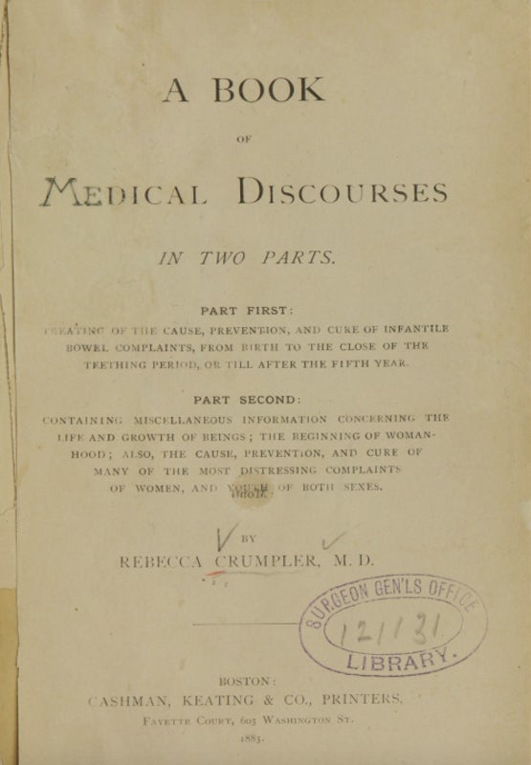

Crumpler's groundbreaking book. Credit: [Wikimedia](https://commons.wikimedia.org/wiki/File:Crumpler_A-Book-of-Medical-Discourses.jpg)

When [Rebecca Davis Lee Crumpler](https://en.wikipedia.org/wiki/Rebecca_Lee_Crumpler) (February 8, 1831–March 9, 1895) gathered nearly two decades of her journal notes and poured them into a book, she’d already treated hundreds—pro-bably thousands—of women and children. Crumpler had witnessed many lives cut short pre-maturely and believed in the lifesaving power of preventive practices. She wanted other women to gain from her obser-vations and accumulated knowledge. “*I desire,”* wrote the 52-year old Crumpler in her 145-page treatise [**A Book of Medical Discourses in Two Parts**](https://archive.org/details/67521160R.nlm.nih.gov/page/n3/mode/2up)**,** devoted to mothers and children, *“that my book shall be as a primary reader in the hands of every woman; and yet nonetheless suited to any who may be conversant with all branches of medical science*.”

Over the course of Crumpler’s long career she worked for the [*Freedmen’s Bureau*](https://www.archives.gov/research/african-americans/freedmens-bureau)*,* which was tasked with helping formerly enslaved individuals to transition from slavery to freedom and citizenship; ran a busy medical practice in the Beacon Hill area of Boston; educated women about pregnancy and childbirth; and published an important volume on disease prevention.

Born to Absolum Davis and Matilda Webber in Delaware, Rebecca was raised by an aunt in Pennsylvania who de-monstrated a clear gift for healing, though she had no formal training. As a young girl, Rebecca watched her aunt cure many neighbours, later recalling that “*I early conceived a liking for and sought every opportunity to relieve the suffering of others.*” In 1852 when she was 21 years old, she moved to Charlestown Mass., near Boston, where Rebecca set up a nursing practice and married Wyatt Lee (who died in 1863). In her nursing work, she came to the attention of male medical colleagues who encouraged her to apply to the New England Female Medical College (NEFMC), where she was accepted in 1860.

Many mid-19th-century male doctors looked down on the new medical institutions for women, claiming that women were too “sensitive” or that they would not be able to fully understand the scientific curriculum. On the other hand, doctors like Israel Tisdale and Samuel Gregory, the founders of NEFMC (established in 1848, the institution later became part of Boston University) argued that only female doctors could protect female patients from “predatory” and “corrupting” male doctors. These advocates of me-dical education for wo-men supported legislation that enabled women to enter the profession. Crumpler later reflected that “*All honour is due to a far-seeing legislation which has recognized the importance of fitting woman for the great and natural office of nurse, or doctress of medicine.”*

The Boston Herald  announced Crumpler’s graduation from NEFMC on Tuesday, March 3, 1864. Crumpler was the first black female doctor in a field of over 54,000 physicians. Some 300 were women.

The end of the Civil War in 1865 left four million black Americans, as well as hundreds of thousands of poor white southerners, without adequate housing or medical care. Congress created the Freedmen’s Bureau (“the Bureau of Refugees, Freedmen and Aban-doned Lands”). Along with helping to reunite families, resolve land disputes, instil just labour practices and establish schools, the Freedmen’s Bureau formed a much-needed medical branch to combat diseases like cholera and smallpox which quickly became widespread in the refugee conditions and tent-cities in the post–Civil War South. In 1866, the 35-year-old Crumpler, newly married to Arthur Crumpler, signed up to serve in the Freedmen’s Bureau, under the lea-dership of General Orlando Brown in Richmond, Va. She was one of only 23 African American physicians—male or female.

The national humanitarian crisis stirred a sense of Crumpler’s calling. She wrote that *“my mind centered upon Richmond, the capital city of Virginia, as the proper field for real missionary work, and one that would present ample opportunities to become acquainted with the diseases of women and children.”*

She continued: "*During my stay there nearly every hour was improved in that sphere of labour. The last quarter of the year 1866, I was enabled, through the agency of the Bureau under Gen. Brown, to have access each day to a very large number of the indigent and others of different classes in a population of over 30,000 coloured*.”

**A Book of Medical Discourses**

Returning from Virginia to Boston, in 1869, Crumpler set up a medical practice that emphasized care for women and children. Crumpler wanted to reach out to all women about the most “*distressing of their complaints*” and extend her reach beyond the patients that she could treat in person. In 1883, 12 years before her death, Crumpler published A Book of Medical Discourses, offering her accumulated knowledge and medical findings to “*Mothers, Nurses, and all who may desire to mitigate the afflictions of the human race.”*

Medical Discourses, which reads somewhat like a template for the 1980s What to Expect When You’re Expecting, covers pregnancy, nursing, early infancy, teething and common diseases for the first five years. Filled with suggestions and advice for new mothers, Medical Discourses includes war-nings against giving children laudanum for coughs. And she cauti-oned against purchasing the cough syrup sold by druggists since the ingre-dients could be toxic. Crumpler reported that one mother who’d hoped to ease her child’s cough *“had come home to a corpse*.” Her admonition about the importance of a baby’s first wash was followed by a concern that male doctors left the birth scene too soon: “*the male physician does not always remain long en-ough to see this important duty performed.”*

Crumpler similarly advised that “*no baby’s face should be covered* *while asleep*.” And she encouraged new mothers to understand a baby’s cry: “*children cry for pastime; so they should. [Crying] develops the lung and relieves the air tubes of any collection of phlegm.”*

Indeed, Crumpler, who insisted that prevention was a better strategy than treatment, devoted two chapters to the prevention and treatment of cholera infantum. “*There is no doubt that thousands of little ones annually die at our very doors, from diseases which could have been prevented, or cut short by timely aid.”*

In [**Sick from Freedom:African-American Illness and Suffering During the Civil War and Reconstruction**](https://muse.jhu.edu/article/547730/pdf)*,* Jim Downs noted that “*Rebecca Crumpler, the only known black female doctor employed by the Bureau, argued that the factors that caused dis-ease could have been prevented.”*

Indeed, Crumpler’s focus was always on “*the possibilities of preven-tion,”* the central tenet of her book of medical advice. She advocated for families of all income levels to receive proper medical care, as well as diet and nutrition advice that could ward off pre-mature mortalities from serious diseases such as cholera, diphtheria and pneumonia as well as other tragedies and household accidents.

In 2016, Melody T. McCloud, a graduate of Boston University School of Medicine and an obste-trician-gynaecologist who serves as founder/medi-cal director of Atlanta’s Women’s Health Care, urged the university to memorialize Crumpler’s accomplishments. “*Dr. Rebecca Crumpler should be remembered as a role model,”* says McCloud. *“People need to know the courage she showed and what she overcame.”* McCloud, who speaks and writes regularly about systemic racial inequities in medical care, worked with Douglas Hughes, former associate dean of academic affairs at Boston University, on Crumpler’s exhibition. Today, Boston University still showcases the [exhibition](https://www.bumc.bu.edu/busm/2016/03/04/alumni-share-experiences-black-history-at-busm/) in memory of Crumpler’s work along with the achievements of other alumni.

Because of McCloud’s formal suggestion and active promotion, on March 30, 2019, Gov. Ralph Northam issued a proclamation commemorating Crumpler’s “*tremendous accomplishments in medicine”* in Richmond. McCloud hopes to see something even more permanent set up to spread awareness about Crumpler as a historic figure in medicine.

McCloud lauds Crumpler’s perseverance. “*During her work for the Freedmen’s Bureau in Richmond, Virginia, it was reported that the hospitals would deny Crumpler the privileges to admit patients*,” says McCloud. *“Pharmacists didn’t want to honour the prescriptions she would write. She was diminished and harassed by those that claimed the MD behind her name stood for Mule Driver. It hurts me to hear what she endured.”*

McCloud adds, “*I feel that Crumpler overcame incredible odds—and she deserves more national awareness.”*

[Kimberly Nagy](http://www.kimnagy.com/) is a professional writer who covers the underreported accomplishments and perspectives of women in history.

Bron: Scientific American online

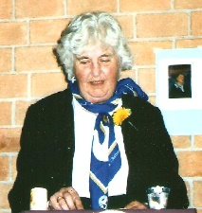**In Memoriam Hanna Deelman**

Hanna was actief lid van WILPF NL, vanaf de her-oprichting van de Neder-landse WILPF-afdeling in 1986.

Hanna was lid van de ‘Congress committee’ , de groep vrouwen die het 23 ste Internationale Congres in Zeist van de WILPF in 1986 organiseerden en ze was tevens lid van de officiële Nederlandse delegatie voor dit Congres.

Ook was zij jarenlang lid van de ‘Kerngroep’ van de Ne-derlandse afdeling, met name als ‘IEC member’.

Na de HBS studeerde ze in TH Delft in de bedrijfsorga-nisatorische richting . Ze werkte bij verschillende overheden. De laatste drie jaar van betaald werk was ze secretaresse en mede-werkster van professor Berenschot. Aan de periode van betaald werk kwam in 1958 een einde door haar huwelijk, want een gehuwde ambtenares was toen nog een wettelijk onmogelijkheid. Toen haar man met pensi-oen ging zei hij: “*Nu kan jij de activiteiten ondernemen die je belangrijk vind en zal ik voor de huishouding zorgen.“*

Ook tijdens de jaren dat zij het huishouden deed was ze actief, o.a. bij de Bond van Plattelandsvrouwen, de plaatselijke Raad van Ker-ken en vandaaruit bij de Nederlandse voorberei-dingsgroep voor de IVde Assemblee van de We-reldraad van Kerken. Ze was deelneemster aan de Oost-West ontmoeting. In 1957 werkte ze mee aan de ‘Emancipaade’ en ze volgde sindsdien met interesse het Decennium van de Vrouw.

In 1975, tijdens de eerste Vrouwen Conferentie van de VN, werd de ‘**UN Decade for Women’** afgekondigd. De besluiten van de Derde Vrouwen Conferentie in Nairobi in 1985 worden vastgelegd in de “Forward Looking Strategies” en kregen binnen WILPF veel aandacht.

Ook tijdens haar lidmaatschap van WILPF blijft Hanna actief in oecu-menische vrouw-en-geloof- groepen.

In 1991 gaat ze als ‘IEC member’ (lid van het Inter-nationale Bestuur van WILPF) - namens de Ne-derlandse afdeling - naar de International Executive Meeting van WILPF in Lillehammer. Daar zijn uit Nederland ook Carlota Lopes da Silva ,als International vicepresident, en Riek van den Berg, als lid van het Finance Committee. Tijdens deze bijeenkomst wordt Hanna en Carlota gevraagd om mee te werken aan de voorbereiding van het Gertrud Bear Seminar op het Internationale Congres in 1992 in Bolivia.

In Bolivia zijn Carlota, Hanna en ook Coby en Mans aanwezig, Mans wordt gevraagd om lid te worden van het ‘finance committee’. De workshop die Nederland voorbereidde wordt positief ontvangen. Coby en Mans zijn in hun element. Coby geeft leiding en Informatie in Engels en Spaans.

1995 vindt het Internationale Congres in Helsinki plaats. Daar waren negen Neder-landse deelneemsters. Zij vergadereden tijden het ontbijt met elkaar om taken te verdelen en standpunten te bepalen. Hieronder een foto.

Vanuit Helsinki vertrok de WILPF PEACE train naar Beijing, op weg naar de vierde UN Vrouwen Conferentie, uitgezwaaid door de congresgangers die niet meegingen, waaronder Hanna.

Hanna werd opgevolgd door Carolien van der Stadt als IEC member.

In 2002 werd zij tegelijk met Carlota benoemd tot erelid van de Nederlandse afdeling van WILPF. Later is ook Mies Brouwer tot erelid benoemd.

De laatste jaren woonde Hanna in Maastricht, dicht bij haar dochter.

Hanna heeft zich in ver-schillende organisaties consequent ingezet voor vrede wereldwijd en de rol van vrouwen daarbij, en wij zijn dankbaar voor haar belangrijke bijdrage aan het werk van WILPF, zowel nationaal als Internationaal.

Han Deggeller en Rosan Huizinga

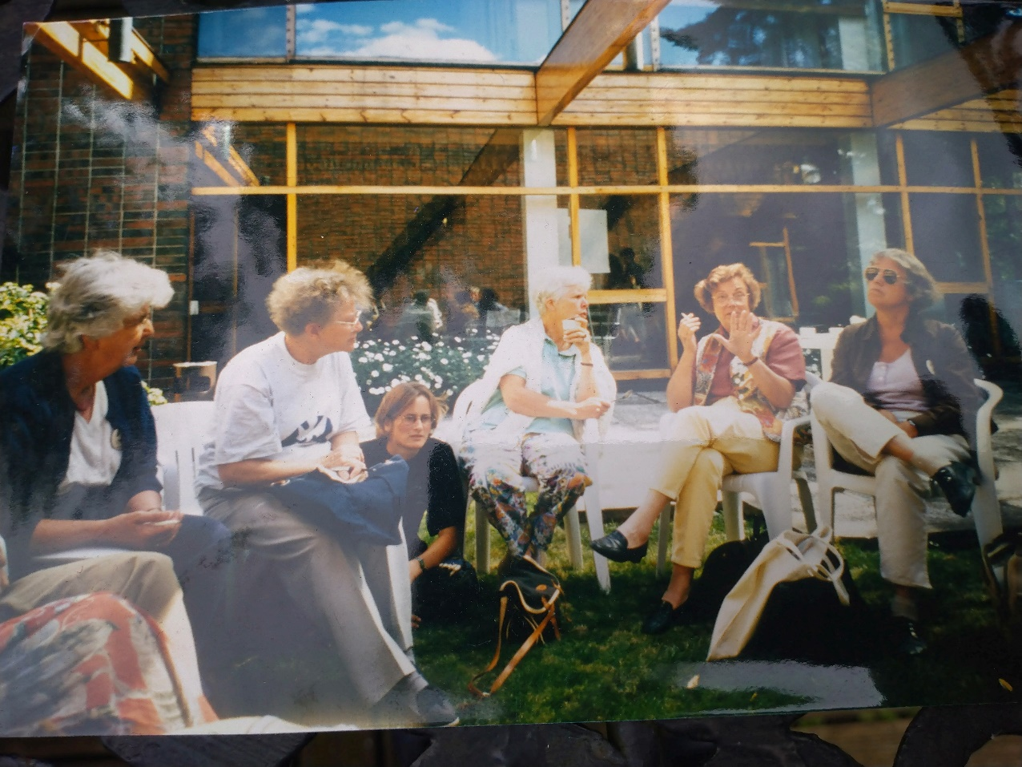*WILPF-Nederland in Helsinki, 1995.vlnr: Hanna, Mies, Froukje, Mans, Carlotta, Loes*

**Bericht van PAX**

*via Daan Kayser, projectleider autonome wapens:*

Aan het einde van de zomer zal  de gezamenlijke commissie van de AIV en CAVV (Commissie van advies inzake volkenrechtelijke vraagstukken) komen met een nieuw advies voor de Nederlandse regering over autonome wapens.

PAX is  daarom een petitie gestart om de regering over te halen om zich aan te sluiten bij een verdrag op autonome wapens: <https://actie.paxvoorvrede.nl/actie/petitie-stop-killer-robots/>

**Landmijnen, we dachten dat we er (bijna) vanaf waren**

Transcript van een gesprek van Amy Goodman en NermeenShaikh van DEMOCRACY NOW, met Jody Williams, ingekort:

**Nobel Peace Prize Winner Jody Williams Slams Biden Admin for Claiming Landmines Are a “Vital Tool”**

In 2014, President Obama banned the military from using landmines anywhere except the Korean Peninsula. But last year, President Trump’s Defence Secretary Mark Esper lifted the restrictions on the use of landmines. On Monday, State Department official Stanley Brown confirmed Trump’s policy remains in effect. So, right now that policy is in effect, as you all know, and we haven’t had any discussions yet in the administration on changing the policy. So, basically, it removed the geographic restriction of Korea, and now geographic commanders can decide the use of landmines, which is a pretty high bar. So, no decision has been made, and no study has been done yet.

**AMY GOODMAN:** So, the next day, on Tuesday, as criticism grew over the issue, Pentagon Press Secretary John Kirby claimed the military is now reviewing the Trump policy. As a candidate, Joe Biden had vowed to promptly roll back what he described as Trump’s “deeply misguided decision.” We’re joined now by Jody Williams. She won the Nobel Peace Prize in 1997 for her work with the International Campaign to Ban Landmines. She led the organizing efforts for the landmark Mine Ban Treaty, which prohibits the use, production, transfer and stockpiling of anti-personnel mines. More than 160 nations have signed the treaty, but the United States has refused to. Jody Williams is also co-founder of the Nobel Women’s Initiative.

**JODY WILLIAMS:** Well, as you know — and thank you for having me back. It has been a long process trying to get the United States to join 164 nations and join the treaty. It’s perplexing, to say the least. The U.S. has not used, it hasn’t exported, it hasn’t produced for decades. There have been multitudinous reviews under various presidents. So, to have President Biden decide now to have another review is quite mind-boggling. And it is, as Amnesty and others said, a deadly and, I would say, retrograde policy to not immediately move back to the Obama position.

**NERMEEN SHAIKH:** Jody Williams, can you explain what the effects of these landmines are and who - what groups - are most vulnerable? Children are, in some places, one in five people who are injured by landmines, and up to 85% of children who are injured by landmines die before they reach the hospital. Could you talk about that, why that’s the case, why children are the most vulnerable, and in what countries landmines are the most widespread?

**JODY WILLIAMS:** Sure. Landmines were invented, if you will, in order to maim people. The thought behind that was if you had a unit of soldiers and a soldier stepped on a mine and got blown up, it would upset — freak out — the rest of the soldiers in this unit. It would take more blood, more operations to help that person. So, when you think about children, how small they are — and stepping on a landmine or picking it up has a devastating effect on kids, older people, women. It is an indiscriminate weapon that has no place on this planet and no place in the ground, in riverbanks where women go and wash clothes, areas where kids play. The fact that President Biden had said he would immediately turn back Mr. Trump’s confused policy and is now having another review is very disturbing.Mines are being used now still in Afghanistan, also in Myanmar, a few other countries. I think it’s about five these days. But many countries are still clearing the mines that had been laid decades ago. It’s a tedious and long-term process to clear landmines.

**NERMEEN SHAIKH:** And in addition to the U.S., Jody Williams, of course, there are other countries that have refused to sign the so-called Ottawa Convention, which limits the use of landmines. Could you explain — talk about what those countries are and where it’s known that those countries have deployed landmines, among them Russia, China, India, Pakistan, etc.?

**JODY WILLIAMS:** It is true that they have not signed. On the other hand, the pressure of the stigmatization of landmines has had an impact on their policy, except for Pakistan and India. China stopped producing for export back in the '90s. Russia has not used them or exported them, either. And this is one of the reasons, when we talk about ban treaties, that they're so important, is that when the whole world, in essence, is saying that a weapon is illegal, indiscriminate, should be banned, the pressure on countries that don’t sign is significant. When India and Pakistan, when their relations get more tense, sometimes along the border they place mostly anti-vehicle mines. But when tensions go down, they remove them. At least they do that. But they should join the treaty, too.

**AMY GOODMAN:** As a presidential candidate, Joe Biden vowed last year to reverse Trump’s policy. In February of 2020, Biden issued this statement to Vox. He said, “The Trump administration’s reversal of years of considered decisions by Democratic and Republican presidents to curtail the use of landmines is another reckless act by a president ill-suited to serve as commander-in-chief. It will put more civilians at risk of being injured by unexploded mines, and is unnecessary from a military perspective. As president, I will promptly roll back this deeply misguided decision.” That was Joe Biden a year ago. So, how do you have then, on Monday, the Pentagon spokesperson defending the continued use of landmines, and then, because of outcry on Tuesday, the Pentagon says, “OK, we’ll review this”?

**JODY WILLIAMS:** Certainly is a contradiction and something that those of us who have fought against landmines for decades do not understand. It was fully expected that President Biden would roll back the policy fairly immediately. I’ve been reading some of the statements of others about it, and Senator Leahy from the great state of Vermont still contends that Biden will reverse the policy. I would suggest to Senator Leahy and others who support banning landmines that they pressure him to do it now and not do another military review. When I heard about the review, I actually — “laugh” is not the right word, but I was, like, totally confused, because it’s been reviewed time and time and time again. How many more reviews does one need to do to know that those weapons have no place on this planet?

**AMY GOODMAN:** Let me ask you something, Jody. Right now there’s this issue of landmines. The U.S. won’t sign onto the treaty and says it will continue the policy that Trump promoted, so landmines can be placed beyond Korea. And that’s another question: Why even in Korea? And at the same time, you have the U.S. being criticized by so many countries around the world for blocking agreements that would allow countries to get vaccines cheaply. So, the U.S. will not be a part of ensuring the world can get vaccines, but stands there with those who are pushing landmines around the world.

**JODY WILLIAMS:** It is mind-boggling. Again, I can’t quite imagine what President Biden is thinking. It is seriously confusing. Let me say, though, the U.S. Campaign to Ban Landmines is putting tremendous pressure on the president and everybody in the administration to change that policy.You know, the U.S., under Mr. Trump, as we all know, tried to withdraw from every international treaty, especially those dealing with weapons. And Mr. Biden had talked about multilateralism and working with the world community and bringing us back into, you know, the international community in a leadership role. You cannot lead from the rear. If you want to really be a leader, you need to deal with the global community, not just your own. So, hopefully, our pressure will get him to change his mind and ban them now.

**Killer Robots**

**AMY GOODMAN:** Finally, you deal with the issue of killer robots. We don’t have much time, but we don’t want to skip over this critical area that not a lot of people know about. What are killer robots, and what’s happening with them now?

[[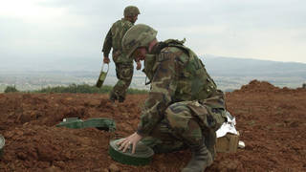](https://www.democracynow.org/2021/4/8/joe_biden_us_landmines_policy)](https://www.democracynow.org/2021/4/8/joe_biden_us_landmines_policy)

**JODY WILLIAMS:** Killer robots are a marriage of artificial intelligence and lethal weapons. You take the drone that can fly on its own, at least there is still a human being who sees the target and makes the decision to hit the target. A killer robot has no human being in the loop. They are programmed. They are set free. And then they make the life-and-death decision over human beings — a machine. Some in the campaign have called it death by machine. It’s terrifying. The U.S. has already tested some intelligent munitions that can communicate with each other once they’ve been fired from an aircraft. And I honestly cannot understand the moral and ethical position of this country that it is OK to allow machines to kill people. It’s mind-boggling.

**AMY GOODMAN:** You wrote, “Why do we glorify violence and war and make peace seem the folly of fools?”

**JODY WILLIAMS:** I think about that all the time. You make a lot of money in war. Peace seems like something for, you know, feather-headed liberals and tree huggers like myself from Vermont. But war is — you know, it’s made heroic. It is not heroic. It is devastating. It is death. It is destroyed civilization. It is insane in this planet today, where we see, with the coronavirus, that everything affects everything. It is time to stop war. It is time to work together — together, excuse me — around the planet for the greater good of us all, is my view.

*Jody Williams received the Nobel Peace Prize in 1997 for her work to ban landmines with the International Campaign to Ban Landmines. She’s co-founder of the Nobel Women’s Initiative.*

*Bron: democracynow.org.*

# Nederlandse feministe Aletta Jacobs inspireert Argentijnen

[*Nina Jurna*](https://www.nrc.nl/search/?author_filter=Nina%20Jurna)*,* [*Natasja de Winter*](https://www.nrc.nl/search/?author_filter=Natasja%20de%20Winter)

*Bron: nrc* [*31 maart 2021*](https://www.nrc.nl/nieuws/2021/03/31/) *Ingekort)*

De avond valt en het leven op het Houssay plein, vernoemd naar de beroemde Argentijnse fysioloog en Nobelprijswinnaar Bernardo Houssay, barst los…. Bij de ingang aan het hek hangt een poster met de aankondiging in het Spaans van een audio-theatertour over het leven van de Nederlandse feministe Aletta Jacobs. ‘**Aletta Jacobs, pionera’** staat erop. Een groep van zo’n twintig mensen met koptelefoons op en mondkapjes voor schuifelt onder leiding van gids Lucia Aduriz rustig over het plein. Terwijl er om hen heen van alles gebeurt, houdt Aduriz foto’s van Aletta Jacobs omhoog en vertelt over het leven van de beroemde feministe. Plotseling blijft de groep staan bij een reeks stenen pilaren met bustes erop. *„Kijk goed”*, horen de deelnemers een stem zeggen via hun koptelefoon. *„Valt het jullie niet op dat hier alleen maar bustes van mannelijke artsen staan?”*

*„Ik had nog nooit van Aletta Jacobs gehoord”,* zegt de 24-jarige Daira Yaconis, die meedoet aan de audio-theatertour. *„Maar haar verhaal als eerste afgestudeerde vrouw aan de universiteit en arts met de eerste praktijk voor vrouwen is indrukwekkend. Haar strijd voor vrouwenrechten was meer dan honderd jaar geleden, maar er zijn veel overeenkomsten met de huidige situatie van vrouwen in Argentinië.”*

***Aletta Jacobs, pionera****(poster van de voorstelling)*

## **Universeel**

Hoewel Aletta Jacobs (1854-1929) in een andere tijd leefde en Nederlandse was, is haar verhaal universeel. En dus is haar strijd inspirerend voor de vrouwenstrijd in Argentinië, die zo’n vijf jaar geleden losbarstte na de zoveelste gruwelijke verkrachting van een jonge vrouw met dodelijke afloop. Dat zag ook de in Buenos Aires wonende Nederlandse producent van de audio-theatertoer, Silvia Rottenberg. Zij organiseert verschillende activiteiten waaronder culturele projecten. *„In Argentinië is al een paar jaar deze zogeheten groene golf gaande”,* zegt ze. *„Vrouwen uit alle leeftijdsgroepen en klassen strijden niet alleen voor gelijke rechten en het recht op abortus, maar ook tegen de vele verkrachtingen en feminicides.”* Het idee ontstond om vanuit deze actualiteit iets te doen rondom de Nederlandse feministe Aletta Jacobs. Omdat er geen bestaand theaterstuk was, ging het instituut samen met de Argentijnse dramaturge Cecilia Meijide aan de slag. „Ze heeft het verhaal van Aletta Jacobs ver-Argentijnst en heeft zich laten inspireren door de honderden brieven die bewaard zijn gebleven van vrouwen over de hele wereld die schreven aan Aletta Jacobs”, zegt Rottenberg. *„Ze stelden haar vragen over bijvoorbeeld geboortebeperking en het beëindigen van zwangerschap, of over hun lichaam. Jacobs was de eerste arts die werkelijk aandacht had voor de anatomie van het vrouwenlichaam, tot dan toe ging dat alleen over de man.”*

De brieven aan Jacobs vormen een rode draad in de tour. Het zijn vragen die nog altijd actueel zijn in het huidige, oerkatholieke Argentinië, waar abortus tot voor kort streng verboden was. „Dit theaterstuk komt op het juiste moment voor Argentinië”, zegt gids Lucia Aduriz, die het publiek over het plein op sleeptouw neemt. Tussen de chaotische taferelen van de vrijdagavond door – er wordt op het plein zumba gedanst, geschermd, geborreld en gegeten – zijn er stiltes in de audio-theatertour waarbij de deelnemers geconfronteerd worden met de ongelijkheid van vrouwen. Zo spreekt Aletta Jacobs de deelnemers rechtstreeks toe ‘vanuit de hemel’, waarbij haar stem wordt vertolkt door de beroemde Argentijnse actrice Cristina Banegas. „*Zien jullie die beelden daar aan de voorkant van de medische faculteit? Waarom staan er geen vrouwelijke artsen tussen?*” vraagt Jacobs het publiek.

## **Machocultuur**

De Argentijnse vrouwenbeweging mag dan vorig jaar na een lange strijd een historisch succes hebben geboekt toen abortus werd gelegaliseerd, er valt nog genoeg te bevechten. Moord op vrouwen komt in Argentinië bijvoorbeeld buitengewoon vaak voor: gemiddeld wordt hier om de dertig uur een vrouw vermoord omdat ze vrouw is. „*Ik voel me vaak niet veilig op straat. Er moet hier nog heel veel verbeterd worden voor vrouwen, we leven in een machocultuur*”, zegt deelneemster Daria Yaconis.

Met strakke blik houdt de gids nu foto’s omhoog van de universiteit waaraan Aletta Jacobs studeerde. En foto’s van haar medestudenten, uitsluitend mannen. Rosa Spanto (65), met rood mondkapje voor en een wandelstok in haar hand, moet door het optreden vanavond terugdenken aan wat ze zelf in 1980 meemaakte. Ze werkte toen als boekhoudster bij een grote bank. „*Ik probeerde daar een betere positie te krijgen, ik was namelijk te hoog opgeleid voor het werk dat ik deed. Toen ik uiteindelijk de moed had en vroeg om salarisverhoging, werd dat afgewezen. ‘Omdat je vrouw bent’*, was de uitleg.”

Tijdens de tour krijgen de vrouwen opdracht om netjes te gaan zitten volgens de regels van toen: met de benen over elkaar. Aan de mannen worden kennisvragen over onder meer vrouwenrechten gesteld. Opnieuw klinkt de stem van Aletta Jacobs door de koptelefoons. Ze vraagt het publiek waarom haar vrouwelijke collega-artsen uit Argentinië niet aanwezig zijn op het plein. Waar is bijvoorbeeld een buste of standbeeld van de Argentijnse arts en feministe Cecilia Grierson, een tijdgenote van Jacobs? „*Het wordt tijd dat we ook onze eigen vrouwelijke helden gaan eren*”, zegt gids Lucia Aduriz. De deelnemers knikken. Het wordt hoog tijd dat de ruimte op het plein gedeeld gaat worden met de vrouwelijke medische helden van Argentinië, zodat de herinnering aan hen hier ook een plek krijgt.

Terwijl de wereld zich bezeert  
  
Zo opgevoed ontstond het plichtsgevoel  
dat lag te piekeren in mijn hand:  
de slapeloze koorts van woorden met een doel,  
een zenuwbaan die stroom verlangt.  
  
Zo opgedraaid kwam ik op deze plek, een tuin  
waarin ik door een vrouw onder een boom  
werd neergezet. Er viel een merel uit de kruin  
die aan mijn voeten hippen bleef.  
  
Hier heb ik het geleerd: stil te blijven zitten  
om een vogel niet te laten schrikken,  
terwijl de wereld zich bezeert.  
Naar deze plek ben ik vaak teruggekeerd.

*Charles Ducal (1952)  
 uit: De koers van de eeuw (2021)*